Halloween Party Appetizers

Mummified Pigs

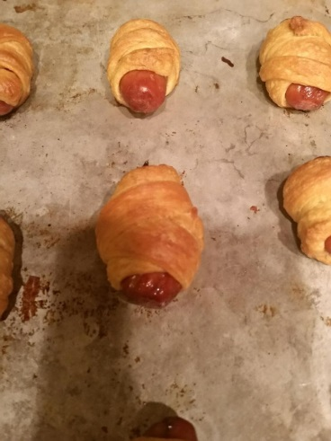

One package Lit’l Smokies, any brand

One package Pillsbury Crescent rolls

Preheat oven to 375 degrees Fahrenheit. Cut crescent roll dough into thin strips. Wrap lit’l smokies in a strip, making sure your wrapping looks a little uneven. Place on an ungreased baking sheet and bake for 15- 20 minutes. Makes 24.

Pumpkin Pie Baked Brie

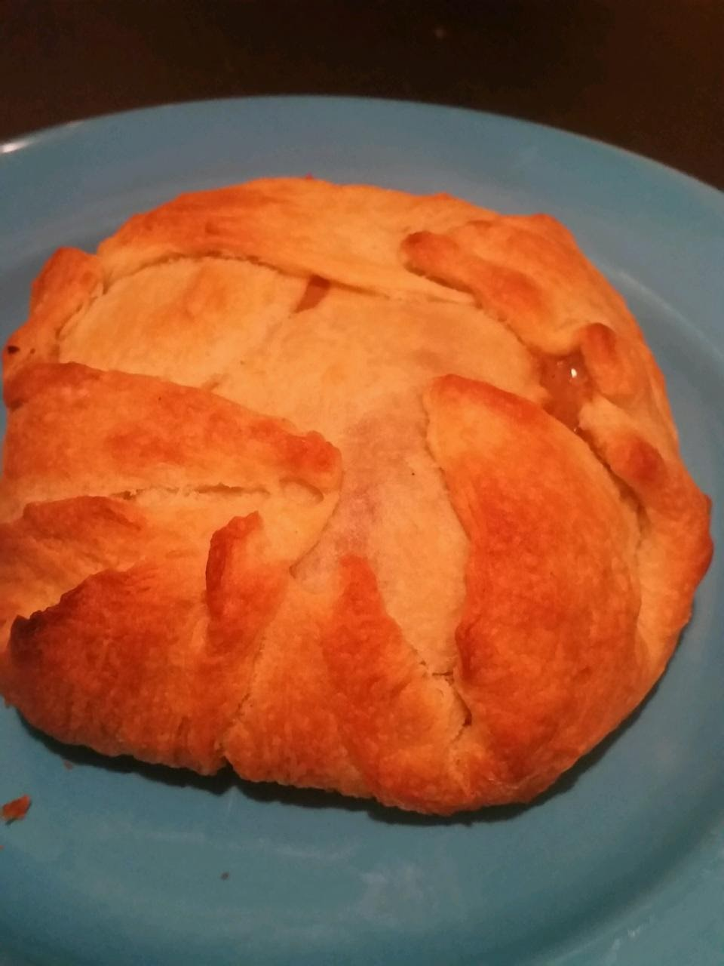

For Pumpkin Pie Filling:

10 oz pumpkin puree

1 tsp pumpkin pie spice

2 tsp cinnamon

½ tsp cloves

½ tsp ginger

1 14 oz can sweetened condensed milk.

Mix All ingredients together in a bowl. Roll out a sheet of four crescent rolls and spread some of the filling on the bottom. Place the brie on top. Spread more pumpkin filling on top (there will be some leftover for your mini pumpkin pies!) Place two additional strips of crescent roll on top and then fold the crescent roll over until sealed. Bake in oven at 375 for 20 minutes.

Vampire Bat Party Wings

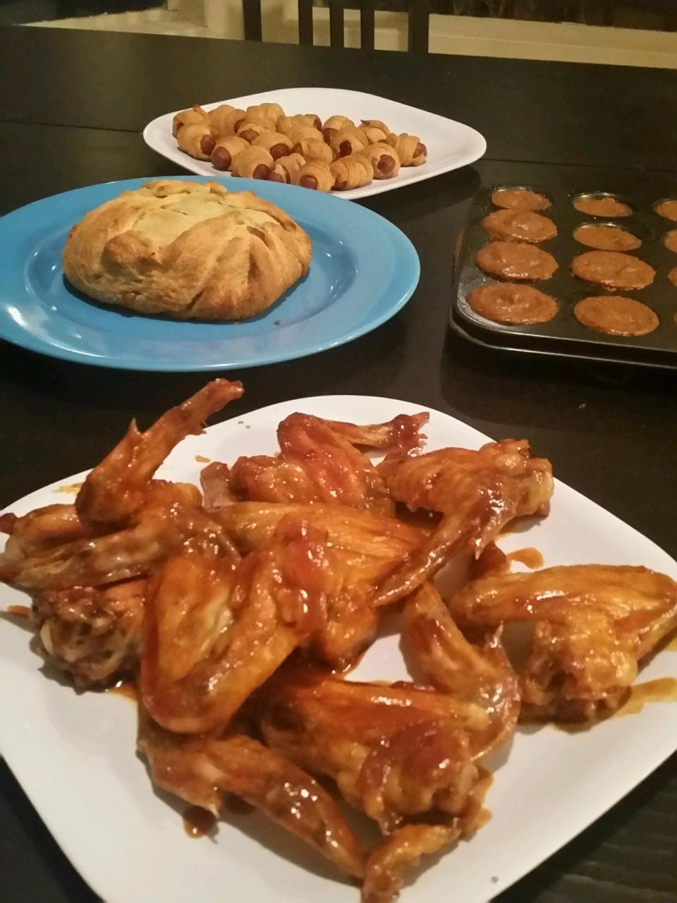

One package bone in, skin on chicken wings

One bottle of General Tso’s sauce

Preheat oven to 375 degrees Fahrenheit. Bake wings for one hour. Then toss in sauce until covered.

Mini Pumpkin Pies

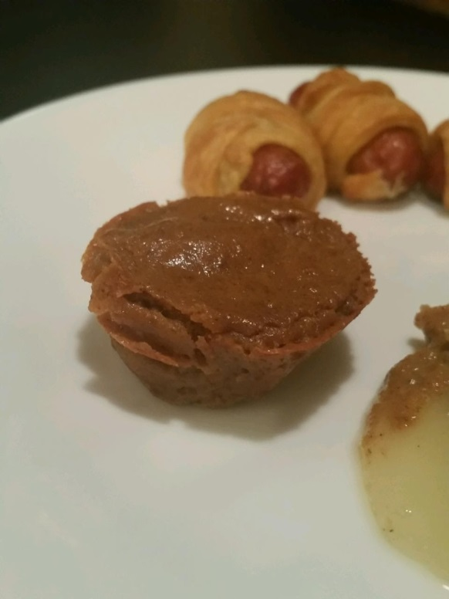

Using the left over crescent rolls from the Brie, tear into small pieces to fit at the bottom of a mini muffin tin. Pour leftover pumpkin pie filling on top until it reaches the top of the mini muffin tin line. Bake at 375 degrees Fahrenheit for 20 minutes.