
Lemon Pancakes with Blueberry Syrup
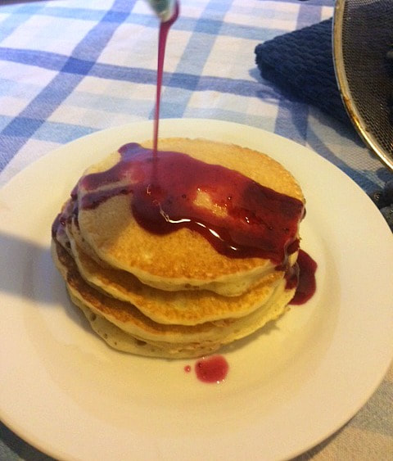
Blueberry Dump Cake in the Crock Pot
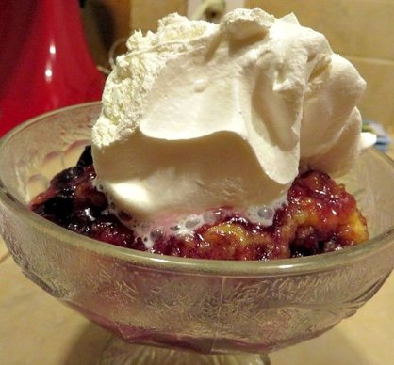
s
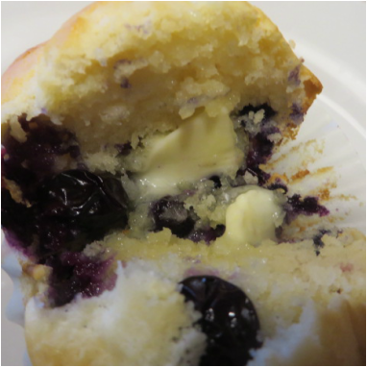
Blueberry Coffee Cake
BLueberry Pancakes
Overnight Blueberry Oats

